## What is Token in C?

**TOKEN** is the smallest unit in a 'C' program.A token is divided into six different types, viz, Keywords, Operators, Strings, Constants, Special Characters, and Identifiers.

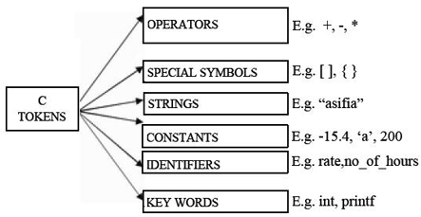

**Keywords and Identifiers**

In 'C' every word can be either a keyword or an identifier.

Keywords have fixed meanings, and the meaning cannot be changed. They act as a building block of a 'C' program. Keyword serve as basic building blocks for program statements. There are a total of 32 keywords in 'C'. Keywords are written in lowercase letters.

Following table represents the keywords in 'C'-

|  |  |  |  |
| --- | --- | --- | --- |
| auto | double | int | struct |
| break | else | long | switch |
| case | enum | register | typedef |
| char | extern | return | union |
| const | short | float | unsigned |
| continue | for | signed | void |
| default | goto | sizeof | volatile |
| do | if | static | while |

**Identifier**

An identifier is nothing but a name of a variable, function, etc. Identifiers are the user-defined names and consists of a sequence of letters and digits. As the name says, identifiers are used to identify a particular element in a program. Each identifier must have a unique name. Following rules must be followed for identifiers:

1. The first character must always be an alphabet or an underscore.
2. It should be formed using only letters, numbers, or underscore.
3. A keyword cannot be used as an identifier.
4. It should not contain any whitespace character.
5. The name must be meaningful.

**Data type modifiers in C**

In c language Data Type Modifiers are keywords used to change the properties of current properties of data type. Data type modifiers are classified into following types.

* long
* short
* unsigned
* signed

Modifiers are prefixed with basic data types to modify (either increase or decrease) the amount of storage space allocated to a variable.

-